**Write the python program for Cript-Arithmetic problem**

## **AIM**

To implement a Python program that solves the **Cryptarithmetic puzzle** SEND + MORE = MONEY by assigning unique digits to letters such that the arithmetic sum is valid.

## **ALGORITHM**

1. Identify all letters in the puzzle: S, E, N, D, M, O, R, Y.
2. Generate all **permutations of digits 0–9** for these 8 letters.
3. For each permutation:
   1. Map letters to digits.
   2. Skip permutations where S or M is 0 (leading digits cannot be 0).
   3. Convert SEND, MORE, MONEY to numbers using the mapping.
   4. Check if SEND + MORE == MONEY.
4. If the equation is satisfied, print the solution and terminate.

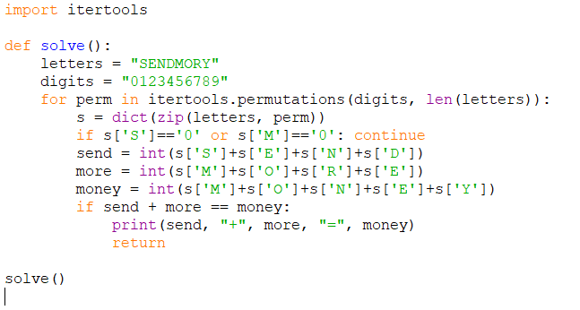

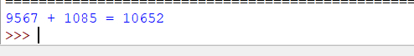

## **RESULT**

The program successfully solved the puzzle and found the digit assignment: